Proponent Guide
to Coordinated Authorizations
for Major Mine Projects

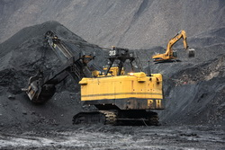

November 15, 2013 – Version 1.0



Disclaimer
This document provides information and advice for those involved in the coordinated review of authorizations for major mine projects. Although references are made to legal requirements, the content of this guide should not be interpreted as legal instructions or legal advice. Users of this guide should refer directly to official copies of the legislation to determine legal requirements and seek qualified legal counsel when case-specific interpretations are needed.
Warranty
While every effort has been made to ensure the accuracy of the information herein, no warranties of any kind are made as to the precision or longevity of the contents.
This information is provided as a public service by the Government of British Columbia. This document and all of the information it contains are provided "as is" without warranty of any kind, whether express or implied. All implied warranties, including, without limitation, implied warranties of merchantability, fitness for a particular purpose, and non-infringement, are hereby expressly disclaimed.
Limitation of Liabilities
Under no circumstances will the Government of British Columbia be liable to any person or business entity for any direct, indirect, special, incidental, consequential, or other damages based on any use of this information or any other document or material to which this document is linked, including, without limitation, any lost profits, business interruption, or loss of programs or information, even if the Government of British Columbia has been specifically advised of the possibility of such damages.
Copyright © 2013, Province of British Columbia
The following policy governs the use of this document and all supporting print, audio and visual files.
All rights reserved
This material is owned by the Government of British Columbia and protected by copyright law. It may not be reproduced or redistributed without the prior written permission of the Province of British Columbia.
Please refer to the Intellectual Property Program’s website for copyright permission requests: http://www.cio.gov.bc.ca/cio/intellectualproperty/copyright.page
Document Change Control
Version | Date | Brief Description of Change
Draft | Jan-Mar 2013 | Draft versions with limited circulation
Draft | April-June 2013 | Post review modifications input from MABC and Government staff
Draft | June 22, 2013 | Revisions to original draft by MEM contractors TH and NR
Draft | July 7, 2013 | Input from EPD and FLNRO. Draft revisions by MEM consultants NR and TH and Chief Inspector’s Office
Draft | July 23, 2013 | Draft changes provided by M. Tassell, FLNRO
Draft | July 29, 2013 | Draft changes by MEM contractors TH and NR
Draft | July 31, 2013 | Information updates from M. Tassell, FLNRO and T. James, EAO added by TH.
Draft | October 28, 2013 | Minor changes to reflect revised MEM/FLNRO Memorandum of Understanding.
1.0 | November 15, 2013 | Draft status removed.

Table of Contents

Preface 1
Acronyms 1
Key Terms 2
Part 1 Introduction 4
1.1 What is the Coordinated Authorizations Process? 4
1.2 The Value of Coordinated Authorizations 5
Part 2 Regulatory Requirements for Mines in BC 6
2.1 Mines Act and Health, Safety and Reclamation Code 6
2.1.1 Mines Act Permit 6
2.1.2 Regional Mine Development Review Committees 6
2.2 Mineral Tenure Act and Coal Act 7
2.3 Environmental Management Act 7
2.4 Notification Requirements Under the Mines Act and Environmental Management Act 8
2.5 Other Provincial and Federal Statutes and Regulations 8
2.6 Relationship to Other Processes 10
2.6.1 Land Use Planning 10
2.6.2 BC Environmental Assessment 10
2.6.3 Canadian Environmental Assessment 11
2.6.4 Strategic Agreements With First Nations 11
Part 3 Roles and Responsibilities 13
3.1 Chief Inspector of Mines 13
3.2 Ministry of Environment – Environmental Protection Division 13
3.3 Project Manager for Mine Review Committee 13
3.4 First Nations Consultation Advisor 14
3.5 Project-Specific Mine Review Committee 14
3.6 Regional Mine Development Review Committee 15
3.7 First Nations 15
3.8 Proponent 15
Part 4 Overview of the Coordinated Authorizations Process 17
4.1 Pre-Application Stage 17
4.1.1 Outreach 18
4.1.2 Project Description 18
4.1.3 Scoping 19
4.1.4 Determining Which Applications to Bundle 19
4.1.5 Planning First Nations Consultation 19
4.1.6 Application Requirements 20
4.2 Initial Submission and Screening Stage 20
4.3 Applications Review Stage 21
4.3.1 Review Initiation 21
4.3.2 Public Review and Comment 21
4.3.3 First Nations Consultation and Accommodation 21
4.3.4 Technical Review by Mine Review Committee 23
4.3.5 Reporting and Decisions Stage 23
Part 5 Opportunities and Challenges 24
5.1 First Nations Considerations for Proponents 24
5.2 Opportunities to be Proactive During the Prospecting and Explorations Stage 25
5.3 Opportunities to be Proactive During the Feasibility and Planning Stage 25
5.4 Opportunities to be Proactive During the Environmental Assessment Stage 26
5.4.1 Concurrent Approval Regulation in Relation to Coordinated Authorizations Process 26
5.5 Deciding What Applications to Bundle 27
Part 6 Authorization Essentials 28
6.1 Ministry of Energy and Mines 31
6.1.1 Convert Mineral Tenure 31
6.1.2 Store and Use Explosives 32
6.1.3 Construct, Operate and Close a Mine 33
6.2 Ministry of Environment 34
6.2.1 Waste Discharge Authorizations 34
6.2.2 Dispose Sewage 36
6.2.3 Dispose/incinerate refuse 38
6.2.4 Store Fuel 40
6.2.5 Concrete Batch Plants (permanent or temporary) 42
6.2.6 Open burning 43
6.3 Ministry of Forests, Lands and Natural Resource Operations 44
6.3.1 Occupy Crown Land 44
6.3.2 Inspect, Investigate, Alter Archaeological/Heritage Site 45
6.3.3 Change In/About Streams or Divert/Use Water 46
6.3.4 Remove groundwater 47
6.3.5 Cut and Remove/Destroy Crown Timber 48
6.3.6 Construct and Use Road 49
6.3.7 Wildlife Salvage and Removal 50
6.3.8 Use Existing Industrial Road 50
6.4 Ministry of Transportation and Infrastructure 52
6.4.1 Connect, Cross or Use Highway Right of Way 52
6.4.2 Rail Access and information links 53
6.5 Health Authorities 53
6.5.1 Supply Drinking Water 53
6.5.2 Food Premises 54
6.5.3 Sewage Disposal 55
6.5.4 Camp construction 55
Part 7 Contacts and Linkages 56
7.1 First Nations Consultation – Information for Proponents 56
7.2 Contacts 56
7.2.1 Chief Inspector of Mines 56
7.2.2 Ministry of Energy Mines Regional Offices and Contacts. 56
7.2.2 MFLNRO Major Projects Offices 57
7.2.3 Ministry of Environment - Environmental Protection Office 58
APPENDIX 1 Project Description Template 59
APPENDIX 2 Detailed Mine Life Cycle 60
APPENDIX 3 Coordinated Authorizations Process for Mines 61
APPENDIX 4 Consultation Information Checklist, Tracking and Logs 62
APPENDIX 5 Proponent Engagement Communication Log 64
APPENDIX 6 Proponent Engagement Interests/Concerns Tracking 65
APPENDIX 7 Proponent First Nations Engagement 66

Preface
This guide is intended for proponents of major mine projects preparing to apply for multiple permits, licences or other authorizations to construct and operate a mine in the Province of British Columbia. For the purpose of this guide a major mine is an operating mine as defined in Section 10.1.2 of the Health, Safety and Reclamation Code for Mines in British Columbia (Code), and refers to all new and existing coal and metal mines which the Chief Inspector of Mines has referred to the coordinated authorizations process.
In the past, multi-agency standing regional mine development review committees established under Section 9 of the Mines Act and reporting to the Chief Inspector of Mines oversaw the application process for a Mines Act permit review, but the proponent was left to pursue other required authorizations independently. The lack of coordination sometimes resulted in duplication of effort in identifying issues and information requirements, as well as inefficiencies and delays with First Nations consultations and government decision-making. In order to improve coordination and provide efficiencies for a mine proponent seeking authorizations from the other natural resource agencies, the Province of British Columbia has therefore implemented a coordinated authorizations process for major mine projects.
This guide provides an overview of the regulatory requirements for mines in British Columbia as well as the coordinated authorizations process, a summary of the roles and responsibilities of participants in the coordinated authorizations process, a discussion of potential opportunities and challenges for consideration by proponents, and detailed information and links to individual permitting agencies, designed to assist proponents in identifying issues and information requirements to be addressed at permitting.

Acronyms
EAO Environmental Assessment Office
FLNRO Ministry of Forests, Lands and Natural Resource Operations
MEM Ministry of Energy and Mines
Code Health, Safety and Reclamation Code for Mines in British Columbia
MOE Ministry of Environment
MRC Project-specific Mine Review Committee
NRS Natural Resource Sector
MDRC Regional Mine Development Review Committee
SDM Statutory Decision Maker

Key Terms
Authorizations are permits, licences or approvals for activities required by legislation. This guide focuses on the authorizations required for the construction, operation and closure of a major mine.
Coordinated Authorizations Process is a process implemented largely through a project-specific mine review committee to coordinate the multiple authorizations that may be required from the various natural resource agencies for new or expanded major mine projects.
Major mine project, for the purposes of this guide, is a coal or metal mine which the Chief Inspector of Mines has referred to the coordinated authorizations process.
Code in this guide is the Health, Safety and Reclamation Code for Mines in British Columbia established under the Mines Act.
Mine Review Committee (MRC) in this guide is a project-specific advisory committee of provincial and federal government agencies, local governments and First Nations established by the Chief Inspector of Mines in consultation with FLNRO for a specific mine project, and is the primary forum for the coordinated authorizations process. The MRC satisfies the requirement under Section 9 of the Mines Act to act as a regional advisory committee specific to the major mine project under review.
Memorandum of Understanding in this guide refers to an agreement reviewed annually between the Ministry of Energy and Mines (MEM) and the Ministry of Forests, Lands and Natural Resource Operations (FLNRO) to reflect the Province’s commitment to reduce the regulatory burden and duplication through a co-ordinated and integrated approach to natural resource management. The memorandum establishes an agreement between MEM and FLNRO regarding the review and permitting of proposed major mines requiring multiple authorizations.
Natural Resource Sector (NRS) is comprised of six BC Public Service ministries - Aboriginal Relations and Reconciliation, Agriculture, MEM, Natural Gas Development, Environment (MOE), including the Environmental Assessment Office (EAO), and FLNRO.
Project manager in this guide means a person assigned by FLNRO to lead and manage the coordinated authorizations process for a major mine project referred to FLNRO by the Chief Inspector of Mines.
Proponent in this guide means the applicant or holder of a mineral or coal tenure who proposes to construct or modify and operate a major mine project.
Regional Mine Development Review Committees (MDRCs) are standing regionally-based inter-agency advisory committees established under Section 9 of the Mines Act to review applications for authorizations under the Mines Act referred to them by the Chief Inspector of Mines, and to make recommendations to the Chief Inspector. In the context of the coordinated authorizations process, regional MDRCs provide a single window inter-agency venue for prospective major mine proponents who may enter the coordinated authorization process, to establish communication with NRS ministries for early outreach and pre-application discussions prior to the Chief Inspector of Mines making a decision on referring the project to a project-specific MRC. As well, the regional MDRCs provide a venue for coordinating the review of permit amendment applications, reclamation and closure plans and follow-up and monitoring programs during the operations, closure and post-closure stages of a mine project.
Tenure with respect to major mine projects means mineral claims and leases under the Mineral Tenure Act and coal licenses and leases under the Coal Act.

Although this guide cites specific legislation, government policies and other documentation, it is only included for the user’s convenience. Users should be aware that some of the legislation, policies and documents cited are subject to review and change from time to time. Users should therefore refer to official copies of the legislation, and should contact the appropriate government offices directly to determine legal requirements and confirm that they are referencing the most up to date policies and documentation.

Introduction
The Province of British Columbia recognizes the value and importance of mining and has put in place changes that are improving the way that natural resource agencies respond to mine proposals.
British Columbia’s Natural Resource Sector (NRS), comprising the ministries of Aboriginal Relations and Reconciliation, Agriculture, MEM, Natural Gas Development, MOE including the EAO, and FLNRO has adopted the vision that BC’s land base be managed in a coordinated and seamless way. By adopting a “One Land Base – One Land Manager” approach, the NRS ministries are working in a collaborative way, along with their counterparts in other provincial, federal and local government agencies and with First Nations, to streamline permitting decisions to encourage economic development while striving to better understand and manage potential impacts to environmental, social, and cultural values.

What is the Coordinated Authorizations Process?
In 2011, under a Memorandum of Understanding between MEM and FLNRO which was amended in 2012 and again in 2013, it has been agreed that, once a major mine project advances to a stage where multiple authorizations are required, the Chief Inspector of Mines may establish a project-specific Mine Review Committee (MRC) to coordinate and review the applications and provide advice to statutory decision makers (SDMs). As well, the Chief Inspector of Mines may request that FLNRO chair the committee and lead First Nations consultations on behalf of MEM. Once a project-specific MRC is established, FLNRO assigns a Project Manager to manage the review process and a consultation advisor to lead First Nations consultations.
Under the Memorandum of Understanding, the coordinated authorizations process is defined as a process initiated by the MRC aimed at harmonizing First Nations consultation and coordinating the review of multiple authorizations that may be required from the various natural resource agencies for new or expanding major mines. The coordinated authorization process is meant to improve consistency, eliminate overlap and duplication in process and information requirements by the various natural resource agencies. The MRC is strictly an advisory committee, and the SDMs maintain responsibility for their respective individual permitting decisions.
For the purposes of the coordinated authorizations process, a major mine refers to any new or existing coal or metal mine which requires multiple authorizations and which has been referred to the coordinated authorizations process by the Chief Inspector of Mines or a delegated Chief Inspector. There are three different routes for a major coal or metal mine project to come into the coordinated authorizations process:
- a new major mine project proceeding from the provincial environmental assessment process under the Environmental Assessment Act;
- a new major mine project that is non-reviewable under the Environmental Assessment Act; or
- a major mine project that is an extension, expansion or re-start requiring multiple authorization amendments.

The Value of Coordinated Authorizations
The coordinated authorizations process strives to reduce time, expense and risk while improving decisions. Streamlining and coordinating the permit application process provides benefits for the proponent, First Nations, the public and government.
The Proponent of a major mine will have a government project manager assigned to coordinate the review process and with the assistance of technical staff of SDMs, provide the proponent with a better understanding and greater certainty about application requirements. Proponents have the opportunity to bundle applications into a single submission to gain efficiencies in application documentation, First Nations consultation and agency reviews.
First Nations are able to assess the project as a whole within a harmonized consultation process instead of having to respond to a series of piecemeal consultations.
Public safety, environmental and economic interests are served by informed and durable decisions supported by a comprehensive review.
Government staff and resources are used more effectively and efficiently. Facilitated coordination of natural resource agencies can improve consistency of approach, reduce overlap and share expertise.

Regulatory Requirements for Mines in BC

Mines Act and Health, Safety and Reclamation Code

Mines Act Permit
The Chief Inspector of Mines is the senior SDM for all mines in the province under the authority of the Mines Act and Code. Under Section 10 of the Mines Act, the owner, agent or manager of a mine must hold a permit issued by the Chief Inspector before starting any work in, on or about the mine. A Mine Act permit does not expire and can only be closed by the Chief Inspector of Mines once the reclamation obligations have been satisfactorily fulfilled.

Regional Mine Development Review Committees
Under Section 9 of the Mines Act, the Chief Inspector of Mines has established standing regional MDRCs to review applications for mine approvals and permits referred to them by the Chief Inspector. Under Section 10.3.2 of the Code, the MDRC must review every application for a Mines Act permit and make recommendations to the Chief Inspector within 60 days following application.
In the context of the coordinated authorizations process and project-specific MRCs, these standing committees provide a single interagency venue for prospective major mine proponents who may enter the coordinated authorization process to engage in early pre-application discussions with NRS agencies on the process, general information requirements, responsibilities of all parties and next steps. MDRCs can then provide advice to the Chief Inspector of Mines on when to consider referring the project to the coordinated authorization process and a project-specific MRC. The standing MDRCs also provide a single NRS interagency venue for follow-up and monitoring of projects during the operations, closure and post closure stages of a mine, including reviewing reclamation and closure plans and advising the Chief Inspector of Mines on the process to review major mine amendment applications.
For major mines the project-specific MRCs established for the coordinated authorizations process satisfy the requirement for establishing a review committee under Section 9 of the Mines Act for specific projects. The standing MDRCs, however, continue to provide an important role as the advisory committee for interagency review of permit applications for mine operations such as placer mines, sand and gravel pits, rock quarries, industrial mineral quarries and bulk samples.

Mineral Tenure Act and Coal Act
The Mineral Titles office of MEM administers the Mineral Tenure Act and the Coal Act, and manages the recording system for the acquisition and maintenance of mineral and coal tenures in BC.
Under the Mineral Tenure Act, a mineral claim must be converted to a mining lease for any production exceeding 1,000 tonnes of ore per year from each unit or cell.
Under the Coal Act, production of coal from a coal license is limited to a single 100,000 tonne sample for testing purposes. Coal licenses must be converted to coal leases for production above the limit.

Environmental Management Act
In addition to the Mines Act permit, a permit to discharge effluent under the Environmental Management Act is an essential authorization for any activity on a mine that could result in a discharge to the environment. A permit authorizes the discharge of wastes from the mining activity to the environment and sets the terms and conditions under which the discharge may occur so that pollution is prevented. The terms and conditions include limiting the quantity and quality of waste contaminants, monitoring the discharge and the receiving environment, and reporting information to MOE. Permits are ongoing authorizations and may be amended, transferred to other dischargers, suspended or cancelled.
The Environmental Management Act permit application can seek authorization for a major mine’s construction stage (erosion and sediment control) and the operations stage (metal and chemical residues, contact water and tailings). Alternatively, the proponent may opt for a phased approach by only seeking authorization for the construction stage and deferring authorization for the operations stage until engineering is sufficiently detailed.
Part 6 of this guide provides a link to joint information requirements for an application for a Mines Act permit and an Environmental Management Act effluent discharge permit. This information will be updated and is expected to become the provincial standard, designed to reduce duplication and streamline the assessment requirements for these two essential authorizations.

Notification Requirements Under the Mines Act and Environmental Management Act
Applicants for a Mines Act permit are subject to a legal requirement to advertise project proposals upon submission of the application and make information available for public review, with 30 days available for public review and comment. [Part 10.2.1 and 10.2.2 of the Code]
The Public Notification Regulation under the Environmental Management Act places certain notification responsibilities on an applicant for an effluent discharge permit. The regulation is available on the Internet at http://www.bclaws.ca/.

Other Provincial and Federal Statutes and Regulations
Other authorizations typically required for carrying out site preparation (such as clearing and grubbing), construction and operational activities for the mine site area will vary depending on the project. As well, authorizations are normally required for mine-related activities and infrastructure off the mine tenure. For example, a Land Act tenure and associated authorizations are required for transmission lines and a Special Use Permit under the Forest Practices Code of British Columbia Act – Provincial Forest Use Regulation and associated authorizations are required for access road development on Crown land off mineral and coal tenures.
Figure 1 identifies typical statutory requirements corresponding to the mine development stages. Each requirement will have triggers and processes specified in legislation and policy.
The purpose of Figure 1 is to illustrate the potential number of authorizations and the general timing of requirements through the life of a mine. Note that there are a number of authorization requirements outside of the coordinated authorizations stage (outlined in bold), however Figure 1 is not intended to serve as a comprehensive list. Some requirements, such as those under the Heritage Conservation Act, will need to be considered at the earliest stages to determine if and when requirements will be triggered for a specific project. Part 6 of this guide provides a more complete list of potential authorizations required for a major mine.

Figure 1 – Regulatory Framework for Major Mines

Relationship to Other Processes

Land Use Planning
Provincial land use plans provide the framework and context for setting environmental, social, land use and resource management goals and objectives on Crown land. For some authorizations, land use plans establish legal objectives and policy that decision-makers must consider. Land use plans may also describe considerations relevant to engagement with First Nations and may be the basis for First Nations involvement in the authorizations process. As such, land use plans inform the authorizations process.

BC Environmental Assessment
British Columbia’s environmental assessment process addresses strategic issues with proposed major mine projects while the project is still at the conceptual stage. If a project is reviewable under the Environmental Assessment Act, a proponent must obtain an environmental assessment certificate before authorizations can be issued for the project. The environmental assessment certificate may have conditions which need to be addressed in applications for authorizations and in any associated permits or licences.
The EAO is an independent office that manages the assessment of proposed major projects in British Columbia as required by the Environmental Assessment Act. For more information about the environmental assessment process, refer to the EAO User Guide and other information on the EAO website: www.eao.gov.bc.ca
Concurrent Approval Regulation
The Environmental Assessment Act allows a proponent of a reviewable mine project to apply for concurrent review of one or more applications for authorizations under other enactments (e.g. Mines Act Permit) while undergoing environmental assessment. The Concurrent Approval Regulation imposes timelines on the review of applications but the authorization decision and timeline remains the responsibility of the SDM for that authorization.
The strategic level of information and assessment typically required for the environmental assessment process will usually not be at a sufficient level of detail to fully satisfy the information and assessment requirements for development level authorizations. Proponents who opt for concurrent permitting must therefore be prepared to invest in detailed permit‐level mine planning and design before the project has been approved‐in‐principle by the issuance of an environmental assessment certificate. See Part 5.4.1 for further discussion of the concurrent approval regulation option.

Canadian Environmental Assessment
The Canadian Environmental Assessment Act, 2012 applies to any mine project that is captured by the Regulations Designating Physical Activities. The proponent of such a project is required to submit a project description to the Canadian Environmental Assessment Agency, who determines if a federal environmental assessment is required based on the potential for environmental effects in areas of federal jurisdiction. If a federal environmental assessment is required for a mine project, the assessment is undertaken by the Canadian Environmental Assessment Agency.
The federal Minister of the Environment may also designate a project not identified in regulations if there is the potential for environmental effects in areas of federal jurisdiction or if there are public concerns about such environmental effects.
The Canadian Environmental Assessment Act, 2012 describes two different types of federal environmental assessment that may be required:
- a standard environmental assessment, focused on potential adverse environmental effects that are within federal jurisdiction; or
- an environmental assessment by a review panel of experts, ordered by the federal Minister of Environment. A joint review panel may also be established with another jurisdiction such as a province.
The Canadian Environmental Assessment Act, 2012 establishes timelines for the government to complete its work. It also includes new provisions related to the federal decision statement, compliance and enforcement mechanisms and follow-up programs.
The Canadian Environmental Assessment Agency coordinates the federal government’s First Nations consultation activities during the environmental assessment process.
In the past, BC’s EAO has signed delegation and equivalency agreements with the Canadian Environmental Assessment Agency on a project by project basis. More recently, the EAO has signed an overarching substitution agreement with the federal government to harmonize efforts and minimize duplication. The agreement allows the federal Minister of Environment to recommend that a designated project be exempted from the Canadian Environmental Assessment Act, 2012 where a provincial review process meets all of the conditions for substitution of a process. If substitution is granted, the federal Minister must still make a final environmental assessment decision based on the outcome of the substituted process.
More information is available at: http://www.ceaa.gc.ca/

Strategic Agreements With First Nations
The Province of British Columbia is committed to establishing processes and institutions for shared decision-making about the land and resources and for revenue and benefit sharing with First Nations. There are two types of agreements currently negotiated with First Nations which may apply to a mining project: Shared Decision Making Agreements and Revenue Sharing Agreements.
Shared Decision Making Agreements include:
Strategic Engagement Agreements
Strategic Engagement Agreements establish a Government-to-Government Forum to consolidate engagement between the Province and a First Nations group, and establish a mutually designed comprehensive consultation process with the First Nation.
Reconciliation Agreements
Reconciliation Agreements pursue broad reconciliation objectives with First Nations including commitments to pursue resource revenue sharing, economic development opportunities and socio-cultural initiatives.
As well, there are Economic and Community Development Agreements which are revenue sharing agreements that provide a share of mining tax revenue to First Nations and ensure First Nations support for a new mine or mine expansion. These agreements also establish a consultation process for the project.
These reconciliation tools are designed to support economic development by enhancing certainty regarding land and resource decision making. For more information please visit the Ministry of Aboriginal Relations and Reconciliation website: http://www.newrelationship.gov.bc.ca/agreements_and_leg/index.html

Roles and Responsibilities

Chief Inspector of Mines
The Chief Inspector of Mines is the senior statutory decision maker for all mines in BC, and is the primary contact for major mine permits. The Chief Inspector is also the initial point of intake for applications for major mine permits and permit amendments.
The Chief Inspector of Mines has a statutory authority and obligation to establish a regional advisory committee to review applications for Mines Act permits. Under the Memorandum of Understanding between MEM and FLNRO, the Chief Inspector also has the authority to establish a project-specific MRC in collaboration with FLNRO once a major mine project advances to a stage that requires coordination of multiple authorizations, and to request that FLNRO chair the MRC.

Ministry of Environment – Environmental Protection Division
The MOE Environmental Protection Division develops legislation and policies to manage and reduce discharges of potential contaminants to the environment through the administration of the Environmental Management Act and the regulations authorized under that Act. The Environmental Management Act prohibits the discharge of waste from specified activities, including mining, to the environment unless the appropriate authorization has been obtained.
The Environmental Management Act effluent discharge permit, like the Mines Act permit, is considered to be an essential authorization for any major mine project, as no surface work or effluent discharge to the environment can be started on a mine without those two permits. As such, the SDMs of the Environmental Protection Division and their representatives on the MRC play a key role in the coordinated authorizations process for major mines.

Project Manager for Mine Review Committee
The project manager assigned by FLNRO to manage a project-specific MRC:
chairs the MRC on behalf of the Chief Inspector of Mines and other SDMs;
coordinates and manages the authorizations process in consultation with MRC members;
works with the First Nations consultation advisor to ensure that the Province’s consultation requirements are met with respect to the applications under review; and
prepares and submits a report of the MRC’s technical review to the statutory decision makers at the end of the application review stage.
The project manager has overall responsibility for managing the technical review of applications, tracking issues and information requirements, facilitating communications between committee members and the proponent and managing time lines for actions of the MRC.

First Nations Consultation Advisor
The First Nations consultation advisor assigned to the MRC by FLNRO:
leads and manages the First Nations consultation process;
works with the project manager to ensure efficient and effective communications between the First Nations, the MRC and the proponent; and
prepares and submits a First Nations consultation report to the statutory decision makers.

Project-Specific Mine Review Committee
The project-specific MRC is the overarching committee where application requirements are identified for a specific major mine project and where the application technical review takes place.
Members of the MRC include representatives of SDMs as well as technical advisors of provincial and federal government agencies, representatives of local governments and invited First Nations. A project manager appointed by FLNRO chairs the committee and manages the review process.
The MRC fulfills the requirement for an advisory committee established under Section 9 of the Mines Act and supports the coordinated authorizations process by:
- coordinating the pre-application stage of the coordinated authorizations process once the project has been referred to the project-specific committee to assist the proponent in preparing a package of applications that is ready for review and decisions;
- working cooperatively with the proponent, government agencies, First Nations and communities to enable a coordinated technical review of multiple authorizations required for the major mine project; and
- providing a forum for participating members to consider the proposed major mine project as a whole while reviewing individual authorizations.

Regional Mine Development Review Committee
Regional MDRCs support the coordinated authorizations process by providing a single window inter-agency venue for prospective major mine proponents who may enter the coordinated authorization process, to establish communication with NRS ministries for early outreach and pre-application discussions prior to the Chief Inspector of Mines making a decision on referring the project to a project-specific Mine Review Committee. As well, the MDRCs provide a venue for coordinating the review of permit amendment applications, reclamation and closure plans and follow-up and monitoring programs during the operations, closure and post-closure stages of a mine project.

First Nations
First Nations have potential roles in three settings:
- as a member of the MRC to address technical issues;
- in consultations with the provincial government regarding aboriginal interests; and
- information sharing and engagement with the proponent.
Potentially affected First Nations are invited to sit as MRC members for a major mine proposed within their traditional territories. The role of First Nations representatives as members of a MRC includes:
- representing the interests of their communities;
- identifying those communities and members of the communities that the proponent and government should contact and engage in order to seek advice on community interests and concerns;
- identifying First Nation interests and issues to be addressed in the proponent’s applications for authorizations;
- assisting the mine proponent and government to understand First Nations concerns; and
- working with their communities, other committee members and the proponent to address issues.

Proponent
The proponent is not a member of the MRC but plays an essential role in the authorizations process by placing the project into the process, providing information and making key decisions on timing and sequencing, and participating in the work of the MRC.
The proponent for a major mine project is solely responsible for the business decisions regarding the major mine project, including:
- Deciding whether the project is feasible, when to pursue mine approvals and whether the proponent has the resources and staff to participate in the assessment and authorizations review processes; and
- deciding which, if any, applications to bundle, in consultation with the MRC.
The above business decisions may entail considerations unrelated to the speed and cost of the process, such as the readiness of partners and stakeholders and the status of financing.
In addition to business decisions, the proponent will be expected to support the coordinated authorizations process through:
- establishing relationships with First Nations and engaging in other procedural aspects of consultation as may be required;
- outreach to government agencies and the public
- collecting and distributing information;
- addressing issues raised by the MRC;
- submitting complete applications; and
- attending MRC meetings at the request of the project manager to provide updates and answer questions.

Overview of the Coordinated Authorizations Process
This section of the guide presents a summary of the coordinated authorizations process, which is described in more detail in the document Guide to Coordinated Authorizations for Major Mines, available on the FLNRO website.
Figure 2 summarizes the four stages of the coordinated authorizations process.

Figure 2 – Coordinated Authorizations Process Overview

Pre-Application Stage
The pre-application stage is arguably the most important stage of the process, and requires a collaborative effort by the project-specific MRC participants, the First Nations consultation advisor and the proponent to support an efficient and timely process. There are no statutory timelines in the pre-application stage, and time spent ensuring that the review process is understood by all, that all required authorizations have been identified, and that identification and scoping of issues and information requirements have been thoroughly discussed and agreed to by the MRC will greatly increase the certainty of a timely review.

Outreach
The proponent is encouraged to engage in early outreach to local, provincial and federal government agencies, local communities, and potentially affected First Nations. Ideally, outreach should start well before the proponent enters the coordinated authorizations process, during advanced exploration, project planning and during the environmental assessment process should an environmental assessment precede the coordinated authorization process. At that time, the initial contact by major mine proponents should be to the office of the Chief Inspector of Mines who will refer the proponent to the Regional Director of MEM and the standing MDRC in the region of the project. The MDRC will assist in the early conversations and the beginning of the pre-application stage to ensure that the project proposal is understood, the coordinated authorizations process is discussed and a preliminary identification of issues and next steps are undertaken.
Early outreach using the standing MDRC can assist in the identification and scoping of issues and information requirements in advance of the coordinated authorizations process, providing a smooth transition from the MDRC to the project-specific MRC and contributing to an efficient and timely project review process. Strong relationships, a collaborative information-gathering process and detailed understanding of the potential impacts and benefits of the project at this stage will give parties greater confidence for moving forward.
Proponent-sponsored outreach to the public during early project planning can also contribute to an efficient review process by informing the public and providing the proponent with early identification of public issues and information requirements.

Project Description
The project manager will ask the proponent to provide the project-specific MRC with a project description, providing enough proposed project development and related information to enable the MRC to:
identify project components and activities both onsite and offsite;
identify/confirm with the proponent the list of statutory authorizations to be reviewed by the MRC under the coordinated authorizations process, including any matters of federal interest;
identify the baseline information requirements and impact assessment requirements to satisfy the authorization applications as well as any other issues within current public policy, and identify homes for addressing issues which may be outside the scope of statutory permit ability to address; and
develop the engagement and consultation approach to meeting the government’s duty to consult and accommodate First Nations.
The project description should be based on an understanding of the coordinated authorizations approach to bundling authorization applications to provide for efficient and effective consultation with First Nations and to enable a review of the project as a whole.
If the major mine proposal is proceeding from the provincial environmental assessment process, the proponent will have already prepared a project description that can be updated and expanded as necessary for the MRC.
A template for a project description can be downloaded from http://www.for.gov.bc.ca/major_projects/mining/

Scoping
At this stage, based on a review of a project description, the MRC works with the proponent to identify issues and information requirements, including any conditions or proponent commitments from the environmental assessment process that are within the scope of the MRC’s review. For those issues that are outside the scope of review, it is important to provide an explanation of why they are not to be considered and where in other processes they may be addressed.
Through the project description and ongoing communication with the MRC, the proponent can assist in identifying and scoping project-specific issues and potential impacts.

Determining Which Applications to Bundle
The proponent should work closely with the MRC in the pre-application stage to identify which applications for permits, licenses and other authorizations, if any, can be effectively bundled in the coordinated authorizations process. Although proponents are encouraged to bundle multiple applications to allow a coordinated review, they may have business considerations that will influence which applications to bundle. It is expected that the MRC would respect the proponent’s business considerations. See Part 5.5 for a further discussion of the bundling option.

Planning First Nations Consultation
Although it is the legal duty of the Crown to consult and accommodate First Nations in land use decisions, major mine proponents are expected to identify and engage potentially affected First Nations in information exchange and engagement early in project planning. In some cases, the Province may delegate certain procedural aspects of consultation and engagement to the proponent, such as participating in meetings with First Nations, providing information to First Nations about the proposed project, and discussing possible project modifications to address First Nations interests.
First Nations engagement by the major mine proponent and consultation by the Province occurs throughout a mine’s development, starting from the exploration stage. Planning for First Nations consultation at the coordinated authorizations stage will be in the context of the previous consultations and the previous knowledge and relationships that the Province and proponent have with the First Nations.
The First Nations consultation advisor assigned to the major mine coordinated authorizations process is responsible for the development and implementation of a project-specific First Nations consultation program. Working with the project manager, the MRC and the proponent as appropriate, the First Nations consultation advisor will engage with potentially affected First Nations to develop and agree upon an approach for consultation.
Further information on First Nations considerations for proponents is discussed in Part 5.1.

Application Requirements
Following a review of the project description by the MRC, the project manager will ask the proponent to prepare and submit a draft application requirements document. The document should include a table of contents for the forthcoming bundle of applications and a description of the proposed type and level of information that will address identified issues and satisfy the information requirements for the statutory authorizations being applied for. After feedback from the MRC and revisions as necessary, the accepted application requirements document will guide the proponent in preparation of the draft applications package. It will also provide a means of screening the forthcoming draft applications package to determine if it is sufficiently complete for a full review by the MRC.
Part 6 of this guide provides a link to joint information requirements for an application for a Mines Act permit and an Environmental Management Act effluent discharge permit. This information will be updated and is expected to become the provincial standard, designed to reduce duplication and streamline the assessment requirements for these two essential authorizations. Part 6 also outlines the information requirements for other authorizations that may be required to enable development on the mine site as well as any offsite infrastructure or activities.

Initial Submission and Screening Stage
After completing necessary baseline and assessment studies to adequately address identified issues and potential impacts and meet statutory information requirements, the proponent should submit a draft applications package that meets the application requirements identified in the pre-application stage.
Technical advisors to the SDMs for each authorization under application will, with the assistance of the project manager, then review and screen the draft application within a reasonable timeline; ideally within two weeks for most projects.
As noted above, the application requirements document developed by the proponent and accepted by the MRC members will assist in the screening of the draft application to ensure that it is complete and sufficient for a full review by the MRC. If the technical advisors on the MRC are satisfied with the applications package, the Chief Inspector of Mines will refer the completed Mines Act permit application to the MRC to review, initiating the 60-day review period for a Mines Act permit and concurrent review of the other authorization applications not under the legislated time limit. The MRC strives to complete a review of all submitted applications in a timely way.

Applications Review Stage

Review Initiation
The project manager will inform the proponent that the draft applications for statutory authorizations has been screened and accepted for review. The proponent is responsible for distributing the final application and supporting documentation to MRC members and making it available to the public and other interest groups. Electronic distribution is encouraged where practicable and where it meets the needs of all reviewers.

Public Review and Comment
As noted in Part 2.3, applicants for a Mines Act permit are subject to a legal requirement to advertise project proposals upon submission of the application and make information available for public review, with 30 days available for public review and comment. As well, applicants for an effluent discharge permit under the Environmental Management Act are required to provide public notice of an application in accordance with the Public Notification Regulation, available at http://www.bclaws.ca/.
The MRC will provide direction to the proponent regarding the format and method of public notification, including opportunities to make a joint notification for the Mines Act and Environmental Management Act applications, making the applications available for review and a common public comment review period.
Although members of the public do not sit on the MRC, they have several opportunities to participate in the review of a major mine project and provide information to the MRC and SDMs for consideration in the permitting decisions. Proponents are encouraged to engage the public by sponsoring informational open houses and other opportunities as appropriate in local communities during the project review stage.

First Nations Consultation and Accommodation
Before issuing authorizations for any mining activity, the Province has a legal responsibility to consult and, where appropriate, accommodate First Nations with aboriginal interests in the project area. The Province also has treaty-specific responsibilities where there are established treaty rights. The MRC’s First Nations consultation advisor is responsible for leading and coordinating the First Nations consultation process.
The following is excerpted from the BC Ministry of Aboriginal Relations and Reconciliation webpage: www.gov.bc.ca/arr/consultation/index.html.
The Province is legally obligated to consult and accommodate (where required) with First Nations on land and resource decisions that could impact their Aboriginal Interests.
When consulting, government officials are guided by the interim Updated Procedures for Meeting Legal Obligations When Consulting First Nations. These procedures provide a consistent and transparent process for provincial ministries and agencies, First Nations and proponents while safeguarding Aboriginal Interests in a manner consistent with the law. The procedures provide a baseline for government to meet its legal obligations. They do not replace or supersede the development of treaties, relationships, shared decision-making arrangements or other agreements.
The procedures were released in July 2010 as interim in order to review them with First Nations. To view the document, click on Updated Procedures for Meeting Legal Obligations When Consulting First Nations: Interim.
While the Province is responsible for ensuring adequate and appropriate consultation and accommodation, proponents can be involved in the procedural aspects of consultation by building relationships with First Nations and facilitating the exchange of information. Early outreach and information sharing at the exploration stage by the proponent during the review of permit applications by regional mines inspectors and MDRCs is important to establishing good working relationships with First Nations during the mine planning and application review stages. Proponent-driven initiatives such as modifying mine plans to minimize potential impacts, avoiding sensitive areas, developing mitigation strategies, carrying out environmental monitoring programs or developing benefit and other business agreements with First Nations can also contribute to the decision-making process.
Government officials are directed to the Guide to Involving Proponents When Consulting First Nations. This guide provides operational guidance to decision makers and staff respecting the role of proponents in consultation.
To foster better relationships between business and First Nations, the Ministry of Aboriginal Relations and Reconciliation has released a plain-language guide which provides practical advice on strategies to help businesses develop strong working relationships with First Nations and can be viewed at: Building Relationships with First Nations: Respecting Rights and Doing Good Business (English).
Proponents are encouraged to refer to the additional information regarding engagement with First Nations, including templates for tracking communications and identifying First Nations issues, located in Appendices 4, 5, 6 and 7.

Technical Review by Mine Review Committee
The proponent will be asked to meet with the MRC early in the application review stage to summarize the content of the applications and help kick-start the review. The MRC provides the interagency and First Nations venue for technical review of the applications and for information exchange and discussions among all MRC participants. During the review period mine proponents are also encouraged to work directly with technical staff of individual SDMs to address specific technical issues where appropriate in the interest of efficiency and expediency. The proponent will be expected to address all issues within the scope of review before the final report of the committee is forwarded to SDMs. The project manager will work with the MRC and proponent to find homes for addressing any issues which are outside the scope of the statutory authorizations under review.
Under Section 10.3.2 of the Mines Act, the MRC must strive to complete its technical review of the Mines Act permit application and provide recommendations to the Chief Inspector of Mines within 60 days of receiving the application. The 60-day timeline does not apply to other authorization applications, the First Nations consultation process, or to decision-making and permit issuance.
The goal of the project manager and other MRC members is to work collaboratively and strive to complete the application review stage in a timely manner.

Reporting and Decisions Stage
The MRC is an advisory committee to SDMs and does not have any decision-making authority. At the end of the committee’s review of the applications, therefore, the project manager will prepare a report on behalf of the MRC and submit it to the appropriate SDMs for permit decisions. The report of the committee will contain information on the review process undertaken to address each statutory requirement (including a summary of First Nations and public consultation), details of all of the issues raised and how they were addressed or if not, why not, and matters to be taken into consideration by each SDM in making a decision.
As well, the First Nations consultation advisor for the MRC will prepare a detailed First Nations consultation report for SDMs, identifying First Nations interests and suggested mitigations, providing details of the consultation process, and providing an assessment of how the process satisfied the Province’s legal obligations to consult and accommodate.

Opportunities and Challenges

First Nations Considerations for Proponents
The legal responsibility to consult and, where appropriate, accommodate, lies with the Crown alone, as represented by the SDMs. Project proponents can, however, be of great assistance in building relationships with First Nations and facilitating the exchange of information.
The proponent is advised to engage with all potentially affected First Nations communities in meaningful and collaborative dialogue and relationship building, to gain an understanding of the potential impacts of the project and the First Nations’ expectations for participation in the project.
Key issues that will likely be of interest to the First Nation are:
- wildlife and fisheries harvest activities in the area;
- water quality;
- other traditional use activity (sustenance activities, village sites, spiritual sites, etc.);
- archaeology sites;
- socio-economic impacts; and
- capacity to participate in consultation; and benefit sharing including jobs and contract opportunities.
Research by the proponent on the above issues will also help government determine the scope of provincial consultation that is required for the statutory authorizations. Any studies that have been undertaken that provide ethnographic or legal information about the aboriginal claims (to aboriginal rights and/or title) in the area, and/or the impact of the proposed activity on those claims, will also be of significant value.
Many First Nations will have the internal capacity, or want to develop the internal capacity, to take on a direct role in the collection of the information required by the proponent. Proponents are encouraged to involve First Nations in the collection of information as much as possible, as this is an opportunity to contribute to capacity building and to help First Nations develop a stronger understanding of the project impacts and benefits.
It should be noted that the proponent is not required to provide government with First Nations information that by arrangement with First Nations has been agreed to be treated as confidential.
Project proponents may assist the project manager and the First Nations consultation advisor by advising of any engagement activities with First Nations such as providing mitigation strategies, environmental monitoring or benefit sharing opportunities. Commitments to training programs, employment opportunities or other engagements by the proponent will help secure longer-term relationships with the mining sector in the area and build the capacity for engagement on other projects.
If the proponent’s discussions with First Nations have extended to cover proposed statutory authorizations, it will be of particular value to the MRC to be aware of any mitigation strategies that have been proposed (such as providing a role for First Nations in the environmental monitoring or reclamation). If such strategies have not been identified, the proponent may seek assistance from the MRC at a later stage in the consultation process to secure such longer term commitments, where appropriate, in discussions with the First Nations.

Opportunities to be Proactive During the Prospecting and Explorations Stage
Proponents should be aware of the site inspection requirements under Section 14 of the Heritage Conservation Act which should be conducted as necessary early in the project planning stage, prior to the coordinated authorizations process (see Part 6.2.2). Meeting the requirements of the Heritage Conservation Act will require early contact with the Heritage Conservation and Archaeological Branch of FLNRO. Before any surface disturbance is carried out, potential archaeological and heritage concerns will need to be identified, appropriate assessments may need to be carried out and necessary permits may need to be obtained.

Opportunities to be Proactive During the Feasibility and Planning Stage
The re-activation of the long-standing regional MDRCs in regional centres will provide an opportunity for proponents of major mine projects to engage MEM and other natural resource agencies early in project planning. By meeting with MDRCs and discussing project plans at an early stage, proponents will have an opportunity to seek advice from technical advisors from the key resource ministries and potentially identify likely baseline data requirements or potential hurdles well in advance.
Typically many major mine proponents will be referred to the MDRCs when applying for permits and approvals for advanced exploration activities. That would be a good time to look forward to potential issues and permit application information requirements that might need to be addressed in future project permitting. By engaging government staff on the MDRCs at an early stage, pre-application discussions could begin well in advance of the need for major mine permits, providing an efficient transition into the coordinated authorizations process.

Opportunities to be Proactive During the Environmental Assessment Stage
The type and level of site investigation and baseline studies required for environmental assessment decisions under the BC Environmental Assessment Act are based on conceptual project designs. In preparation for making application for operational authorizations, proponents may want to consider carrying out a more detailed level of information collection than is required to satisfy Application Information Requirements in the environmental assessment process. In particular, authorizations for Mines Act permits and Environmental Management Act permits frequently require detailed baseline sampling programs and protocols, often of a seasonal nature. By collecting critical baseline data prior to entering the coordinated authorizations process, major mine proponents could potentially be saving a year or more of review.

Concurrent Approval Regulation in Relation to Coordinated Authorizations Process
The Environmental Assessment Act Concurrent Approval Regulation allows proponents to apply for concurrent review of applications for other provincial authorizations for a proposed major mine project that is undergoing environmental assessment. This option can allow for timelier issuance of required approvals, assuming that there is a decision to grant an environmental assessment certificate. If this option is pursued, however, the level of information required by the permitting agencies during the environmental assessment will be based on detailed project designs.

For the coordinated authorizations process, an environmental assessment certificate provides the framework for subsequent project authorizations. Permitting agencies will therefore need to consider the information included in the environmental assessment certificate, including the Table of Conditions and Certified Project Description, when identifying and scoping issues to be addressed at permitting. As a result, information requirements for authorization applications cannot be determined with certainty prior to having the certificate in hand. Early discussion about the coordinated authorizations approach as well as proactive identification and collection of required baseline information during the environmental assessment process can, however, help streamline the eventual review of applications for authorizations.

For more information about the environmental assessment process, refer to the EAO User Guide http://www.eao.gov.bc.ca/pdf/EAO_User_Guide%20Final-Mar2011.pdf and other information on the EAO website: www.eao.gov.bc.ca

Deciding What Applications to Bundle
Part of the early pre-application discussions with MRC members and the proponent will include scoping of the list of authorizations, including any federal authorizations that are being applied for, identifying issues and information requirements for each authorization and identifying provincial policy mandates to be addressed. Typical provincial and federal authorizations that may apply to a major mine are listed in Part 6 of this guide. Mine proponents should be aware that the timing of provincial statutory decisions is not necessarily dependant on the timing of federal authorizations, however where provincial authorizations may affect federal jurisdiction, the appropriate federal authorizations are required in advance of any effect on a federal resource or jurisdiction.
The proponent can work closely with the MRC in the pre-application stage to identify which permits, licenses and other authorizations can be effectively bundled in the coordinated authorizations process.
There is no need to bundle every application that will eventually be required, however. It can make sense to have a sequence of bundles of applications and possibly to leave some authorizations for stand-alone applications. One logical division would be between those authorizations required for site preparation and construction and those that are required for operations. At the pre-construction stage, the proponent will likely not have the detailed information necessary for operational authorizations. For example, proponents may need to apply for Environmental Management Act authorizations for erosion prevention and sediment control during site preparation and construction before finalizing applications to authorize operational activities.
In addition to logistics and efficiencies in the authorizations process and ground activities, proponents may have business considerations which will influence which applications to bundle. The MRC should respect the proponent’s business considerations while encouraging the bundling of at least the Mines Act Section 10 permit and the Environmental Management Act effluent discharge permit, as well as any related authorizations required for access and site disturbance, such as a Special Use Permit under the Forest Practices Code of British Columbia Act or Occupant Licence to Cut under the Forest Act.
Tenure conversions (replacement of a mineral claim or coal licence with a mineral lease or coal lease) are essential authorizations that should be considered at the pre-application stage to ensure First Nations consultations are appropriately coordinated. The application for tenure conversion can be made separately, however, and not be included in the bundle of applications to be reviewed by the MRC.

Authorization Essentials

This section provides detailed descriptions and links to the most common statutes and application information requirements, to assist in the preparation of applications for major mine authorizations. This information is provided for the user’s convenience only. Proponents of major mine projects should contact the appropriate government office to obtain project-specific application requirements before preparing or submitting any authorization applications.

Figure 5 on the following page lists possible mine development activities which will require authorization from a provincial government agency.
The following abbreviations are used to identify the responsible agency.
MEM Ministry of Energy and Mines
MOE Ministry of Environment
FLNRO Ministry of Forests, Lands and Natural Resource Operations
HA Health Authority
MTI Ministry of Transportation and Infrastructure

Figure 6 groups the authorizations by responsible agency.
The rest of this part provides essential information for each type of authorization grouped by agency.

Figure 5 – Activities Requiring Authorization
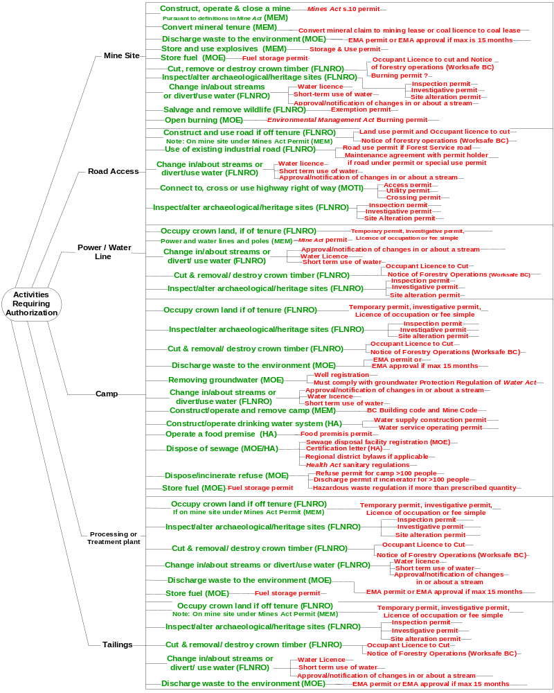
Figure 6 – Authorizations by Responsible Agency
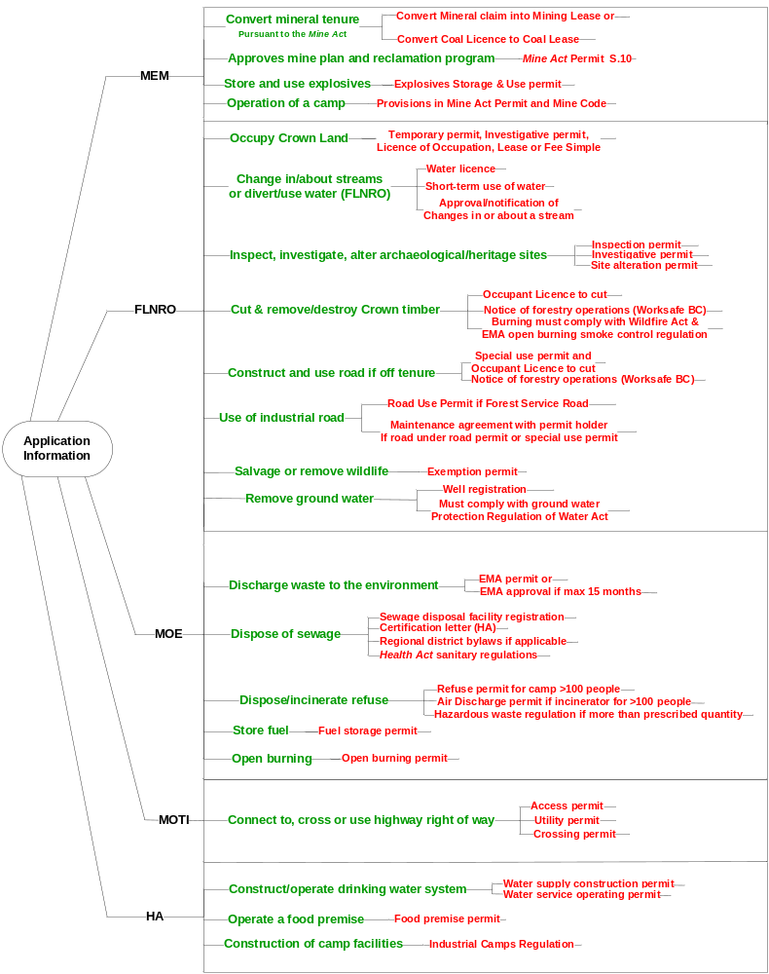

Ministry of Energy and Mines
Authorizations administered by MEM:

Convert Mineral Tenure
Tenure provides an exclusive or preferred right of access to explore for, develop and remove resources. For a major mine, tenure initially comes from a mineral claim under the Mineral Tenure Act or a Coal Act coal licence.
The Mineral Titles Office of MEM administers the statutes and manages the recording system pertaining to the acquisition and maintenance of mineral, placer and coal rights in the Province. More information: www.empr.gov.bc.ca/TITLES/MINERALTITLES
A mineral claim or coal licence must be converted to a mining lease under the Mineral Tenure Act or a coal lease under the Coal Act before production can exceed the limits specified in legislation.

Statute | Tenure | Agency | Purpose
Mineral Tenure Act | Mineral Claim | MEM | Subsurface rights to minerals in a defined unit, up to 10,000 tonnes per year per unit.
 | Mining Lease | MEM | Conversion of mineral claim to a mining lease is necessary before production can exceed above limits.
Coal Act | Coal Licence | MEM | Rights to explore for and develop coal on the licence location up to a single 100,000 tonne bulk sample.
 | Coal Lease | MEM | Conversion of coal license to a coal lease is necessary before production exceeds above limit.

Store and Use Explosives
Activity | Store and use explosives
Authorization | Explosives Magazine Storage and Use Permit
Description | Users must apply for an explosives storage and use permit
Legislation | Mines Act and Code (Part 8)
Agency | MEM
Decision-maker | Regional Mines Office – Inspector of Mines
Technical staff | Available in the regional mines office
Pre-Requisites | N/A
Linkages | (Federal) Department of Natural Resources Explosives Act - For the manufacturing of explosives along with the construction of the explosives plant.
Application Requirements | www.empr.gov.bc.ca/Mining/Permitting-Reclamation/ApplicationForms/Documents/Explosives.pdf
Guidance | - http://www.empr.gov.bc.ca/MINING/Pages/default.aspxhttp://www.empr.gov.bc.ca/Mining/HealthandSafety/Documents/HSRC2008.pdf

Construct, Operate and Close a Mine
Activity | Construct, operate and close a mine pursuant to the Mine Act definition
Authorization | Mines Act Permit
Description | Provides approval for the site preparation, construction, operation and closure phases of project development subject to conditions, provision of further detailed information and assessment as it becomes available and sets out closure and reclamation obligations and security
Legislation | Mines Act section 10  Health, Safety and Reclamation Code for Mines in British Columbia, part 10
Agency | Ministry of Energy and Mines
Decision-maker | Chief Inspector of Mines  6th Floor - 1810 Blanshard Street  Victoria, BC V8W 9N3
Technical staff | Office of the Chief Inspector of Mines
Pre-Requisites | Mineral tenure. Advanced exploration (An ore body)
Linkages | Mines involve discharge of material to the environment and will therefore require waste discharge authorizations under the Environmental Management Act. Since the Mines Act permit and the Environmental Management Act authorizations have significant common information requirements, proponents are encouraged to make a Joint Application.
Application Requirements | Contact the Chief Inspector of Mines Office to obtain the most up to date information about application requirements.  Guidelines for submitting a joint application for a Mines Act permit and an Environmental Management Act permit is available on the Major Projects Office Major Mines webpage: http://www.for.gov.bc.ca/major_projects/mining/  - A public notice of application is to be placed in the BC Gazette and local news media upon application, providing a 30 day public review period.
Guidance | Numerous useful guidance documents can be found at: http:/www.empr.gov.bc.ca/Mining/Permitting-Reclamation/Guidance/Pages/default.aspx  http://www.empr.gov.bc.ca/Mining/Permitting-Reclamation/ML-ARD/Pages/Guidelines.aspx  http://www.empr.gov.bc.ca/Mining/Permitting-Reclamation/Geotech/Pages/default.aspx  Proactive steps the proponent can take:  - Consult early with the Office of the Chief Inspector of Mines

Ministry of Environment
Authorizations administered by MOE:

Waste Discharge Authorizations
Activity | Discharge from the mine site to the environment.  - Effluent discharges (such as acid and neutral rock drainage, tailing pond supernatant, mine influenced run-off and sewage);  - Air emissions (such as refuse incinerator emissions, emissions from large power generating plants, emissions from milling process); and,  - Solid wastes (such as mill tailings, water treatment plant sludge, municipal and industrial refuse).
Authorization | Waste Discharge Permit or Approval
Description | The Environmental Management Act permit application can seek authorization for the site preparation and construction stage (erosion and sediment control and blasting residues) and operations stage (metal/chemical residues and contact water and tailings). Alternatively, the proponent may take a two-step approach to the Environmental Management Act permit by seeking authorization for only the site preparation and construction stage and deferring authorization via a permit amendment for the operations stage until engineering is sufficiently detailed to support an application for amendment to the permit.  Authorizations can take the form of a permit or, for short-term discharges up to 15 months duration, an approval.
Legislation | Environmental Management Act
Agency | Ministry of Environment
Decision-maker | Regional Manager, Environmental Protection Division  Section Head Environmental Quality
Technical staff | Environmental Protection Officer
Linkages | Major mines involve discharge of material to the environment and will therefore require waste discharge authorizations under the Environmental Management Act. Since the Mines Act permit and the Environmental Management Act authorizations have significant common information requirements, proponents are encouraged to make a Joint Application to improve the efficiency of the application/review process.
Application Requirements | Guidelines for submitting a joint application for a Mines Act permit and an Environmental Management Act permit is available on the Major Projects Office Major Mines webpage: http://www.for.gov.bc.ca/major_projects/mining/  Key requirements  - A pre-application meeting for the proponent to provide an overview of the proposal, to confirm with the ministry the requirements set out in legislation and guidelines, and to confirm the level of detail for supporting information required.  - Application form for an Authorization to Discharge Waste http://www.env.gov.bc.ca/epd/waste_discharge_auth/app_forms/  - Application fees  - Several environmental management plans may be required (see guidelines)  - A final Technical Assessment Report may be required  - Notice of application must be published in the BC Gazette and local news media (30 day public notification period) See Environmental Management Act Public Notification Regulation
Guidance | Waste discharge authorizations are concerned with: quantity of effluent, quality of effluent and where is it going. Permit limits are then developed. Meet with Ministry of Environment staff before preparing an application.  General guidance: www.env.gov.bc.ca/epd/waste_discharge_auth/index.htm  Guidance for completing an application form, consultation and technical assessment: http://www.env.gov.bc.ca/epd/waste_discharge_auth/guidance/index.htm  Proactive steps the proponent can take:  - Prepare for pre-application meeting with Environmental Protection staff by becoming familiar with legislation and guidelines.  - Verify acceptability of any emission dispersion model that will be used.

Dispose Sewage
Activity | Construct and use a sewage disposal facility for camps
Authorization | Sewage Disposal Registration and Certification
Description | Sewage Disposal Facility Registration: Authority to construct and use a sewage disposal facility (if necessary depending on design sewage flow of camp) for camps >100 persons.  Certification Letter: A certification letter needs to be filed with Northern Health by an ‘Authorized Person’ for <22,700 L/day of sewage. If >22,700 L/day, then Municipal Sewage Regulation under the Environmental Management Act applies.
Legislation | Registration: Environmental Management Act, Municipal Sewage Regulation  Certification: Public Health Act – Sewage Disposal Regulation
Agency | Registration: Ministry of Environment  Certification: Health Authority
Decision-maker | Registration: Regional Manager, Environmental Protection Division  Section Head Environmental Quality  Certification: Environmental Health Officer, Public Health Protection, Health Authority
Technical staff
Pre-Requisites
Linkages | Compliance with requirements of the Sanitary Regulations of the Health Act  Regional District bylaws if applicable
Application Requirements | Key requirements:  - Registration must be completed 90 days prior to construction.  - Environmental Impact Study and Operations Plan must be completed 90 days prior to construction.  - Discharges cannot contribute to a health hazard  - Only ‘Authorized Persons’ construct and/or maintain on-site sewage systems  - Certified systems must be designed in accordance with the regulations and adhere to performance standards  Public consultation:  - no
Guidance | Registration guidance: http://www.env.gov.bc.ca/epd/mun-waste/  Municipal Sewage Regulation: http://www.env.gov.bc.ca/epd/mun-waste/regs/mwr/ Registration form and guidance: http://www.env.gov.bc.ca/epd/mun-waste/ Environmental Study guidelines: www.env.gov.bc.ca/epd/epdpa/mpp/pdfs/EIS_Guideline_Dec2000.pdf  Operations Plan guidelines: http://www.env.gov.bc.ca/epd/mun-waste/ For certification guidance on regulation, requirements, how to file, and standard practices:  http://www.health.gov.bc.ca/protect/lup_onsite.html  http://www.gov.bc.ca/health/  Authorized Persons: http://www.health.gov.bc.ca/protect/lup_authorized.html Northern Health - Guidelines for Industrial Camps Sewage Disposal  http://www.northernhealth.ca/YourHealth/EnvironmentalHealth/SewageDisposal.aspx  Proactive steps the proponent can take:  - Decide whether to register under the Environmental Management Act Municipal Sewage Regulation or include sewage disposal as part of the effluent permit under the Environmental Management Act. If it is included in the effluent permit, the system would need to meet the basic requirements of the Municipal Sewage Regulation.  - Become familiar with the regulation  - Hold a pre-registration meeting with MOE staff at least 60 days prior to registration

Dispose/incinerate refuse

Activity | Construction Camp
Authorization | Refuse Permit (for camp >100 persons)  Air Discharge Permit (incinerator for camp >100 persons)  Hazardous Waste Registration (if more than prescribed quantity)
Description | The Environmental Protection Program issues Waste Management Permits under the authority of the Environmental Management Act. The permits authorize the discharge of wastes to the environment and set limits on the quantity and quality of the discharge. They also set requirements for monitoring the effect of the discharge on the environment, and any other terms and conditions which may be necessary to prevent pollution.  Refuse Permit: Authorization for municipal solid waste (solid waste from camps >100 persons) - disposal of food wastes for exploration, construction, and industrial camps.  Air Discharge Permit: Authority to discharge air contaminants into the environment, e.g. Incinerator for camps serving >100 persons.  Hazardous Waste Registration: Registration and application for a provincial identification number is required in order to produce, store, treat, recycle or discharge more than a prescribed quantity of hazardous waste within 30 days.
Legislation | Environmental Management Act
Agency | Ministry of Environment
Decision-maker | Regional Manager - EP or Section Head - EP
Technical staff | Environmental Protection Officer
Pre-Requisites | A pre-application meeting with MOE staff (Environmental Protection Officer) is essential to setting the scope of the application and process requirements for these authorizations.
Linkages
Application Requirements | - Incinerator Application Requirements:  - http://www.env.gov.bc.ca/epd/waste_discharge_auth/app_forms/  - Application fees  - Several environmental management plans may be required (proponent to discuss with MOE staff as to what will be required)  - A final Technical Assessment Report may be required  - Notice of application must be published in the BC Gazette and local news media (30 day public notification period) See Environmental Management Act Public Notification Regulation
Guidance | http://www.env.gov.bc.ca/epd/waste_discharge_auth/intro.htm  http://www.env.gov.bc.ca/epd/hazwaste/regs/index.htm  - Ability to submit all the registration applications together as a package (refer  - to Part 4 Division 1 sections 45 and 46 of the MWR for requirements “Before  - discharge begins” and “Notification of discharge”).  Proactive steps the proponent can take:  - Schedule a pre-application meeting with MOE staff (Environmental Protection Officer) to set the scope of the application and process requirements - to provide an overview of the proposal, to confirm with the ministry the requirements set out in legislation and guidelines, and to confirm the level of detail for supporting information required.  - Several environmental management plans may be required (proponent to discuss with MOE staff as to what will be required during the pre-application phase)  - A final Technical Assessment Report may be required

Store Fuel
Activity | Fuel Storage
Authorization | Registration
Description | Any petroleum storage facility that has a cumulative storage capacity over 100,000 L, occupies a location for more than 180 consecutive days and is NOT a part of a retail service station is required to register. The regulation also outlines requirements for oil water separator systems and effluent quality. The BC Fire Code has separate requirements that must also be adhered to.
Legislation | Environmental Management Act – Petroleum Storage and Distribution Facilities Storm Water Regulation
Agency | Ministry of Environment, Environmental Protection Division
Decision-maker | Director or Manager
Technical staff | Environmental Protection Officer or Technician
Pre-Requisites
Linkages | Petroleum Storage and Distribution Facilities Storm Water Regulation  http://www.bclaws.ca/EPLibraries/bclaws_new/document/ID/freeside/38_168_94  BC Fire Code  http://www.bccodes.ca/bccode_fire.htm  Spill Reporting Code  http://www.bclaws.ca/EPLibraries/bclaws_new/document/ID/freeside/46_263_90
Application Requirements | Please note, there is no form or no fee for this regulation but the following information needs to be submitted to register.  Registration of petroleum storage and distribution facilities  7 Every operator must register with a director each petroleum storage and distribution facility under the operator's charge or control by submitting in writing to the director the following information:  (a) the name of the owner or operator;  (b) the address of the owner or operator;  (c) the address of the petroleum storage and distribution facility;  (d) the name and telephone number of a contact person;  (e) the number and total volume of tanks at the petroleum storage and distribution facility;  (f) the volume and capacity of any oil/water separator or treatment device at the petroleum storage and distribution facility;  (g) a description of the discharge point of all separators or treatment devices.
Guidance | A Field Guide to Fuel Handling, Transportation & Storage  http://www.env.gov.bc.ca/epd/industrial/oil_gas/pdf/fuel_handle_guide.pdf

Concrete Batch Plants (permanent or temporary)
Activity | Concrete Production in a batch plant
Authorization | Registration
Description | The code addresses air quality management, discharge of process water and storm water and the management of waste solids — as well as registration, monitoring, record keeping and enforcement.
Legislation | Environmental Management Act – Code of Practise for the Concrete and Concrete Products Industry
Agency | Ministry of Environment, Environmental Protection Division
Decision-maker | Director or Manager
Technical staff | Environmental Protection Officer or Technician
Pre-Requisites
Linkages | Code of Practise for the Concrete and Concrete Products Industry  http://www.bclaws.ca/EPLibraries/bclaws_new/document/ID/freeside/16_329_2007
Application Requirements | Registration Form with submission instructions & $200 application fee  http://www.env.gov.bc.ca/epd/industrial/regs/codes/concrete/pdf/reg_form.pdf
Guidance | Guidance Document available here  http://www.env.gov.bc.ca/epd/industrial/regs/codes/concrete/index.htm

Open burning
Activity | Open Burning (Land clearing debris, construction wastes and other wood wastes)
Authorization | Burning Permit
Description | Open burning of wood debris, generated by activities such as land clearing and forest harvesting, can be conducted in accordance with the Open Burning Smoke Control Regulation. Conditions of the regulation are summarized in Appendix A. Open burning of other waste materials is prohibited.
Legislation | Wildfire Act  Land Clearing Debris – carried out in accordance with the Open Burning Smoke Control Regulation: http://www.bclaws.ca/EPLibraries/bclaws_new/document/ID/freeside/34_145_93  Construction Wastes and other Wood Wastes – requires authorizations under the Environmental Management Act: http://www.bclaws.ca/EPLibraries/bclaws_new/document/ID/freeside/03053_00
Agency | Forests, Lands and Natural Resource Operations (Regional Environmental Protection Office)
Decision-maker | n/a
Technical staff | n/a
Pre-Requisites | n/a
Linkages | Ensure to monitor venting index
Application Requirements | Key requirements:  - Any burning requires a burning reference number.  - Burning reference number contact: 1-888-797-1717
Guidance | A Permit or Approval under the Environmental Management Act is required for open burning operations which do not meet the requirements of the Open Burning Smoke Control Regulation. Contact the regional Environmental Protection office for permit/approval application instructions.

Ministry of Forests, Lands and Natural Resource Operations
Authorizations administered by FLNRO:Occupy Crown Land
Activity | Occupy Crown land for power line right of way, quarry, camp, staging areas, or mine infrastructure off of the mineral tenure
Authorization | Permit, Licence of Occupation, Lease or Sale
Description | Temporary Permit: Issued for temporary use up to two years.  Investigative Use Permit: Issued to any proponent requiring access to the land for appraisals, inspections, analyses, inventories, surveys or other investigations of Crown land or its natural resources, or where otherwise required. No disturbance is authorized and no buildings or other improvements may be placed on the land.  Licence of Occupation: Authorization for power line right of way, quarries, camps and staging areas. Utilities on Crown land, whether buried, hung on poles or sunk/buried under water require authorization.  Lease: A lease should be issued where long term tenure is required, where substantial improvements are proposed, and/or where definite boundaries are required in order to avoid conflicts.  Sale: Crown land sales may occur through an application process if the proposed site meets specific criteria and the use is considered suitable by government agencies and other affected interests.  Only investigative and temporary permits and licences of occupation are used in the early stages of mine development. Licences may be converted to long term tenure, when a project is approved by government. See mining policy at: www.for.gov.bc.ca/Land_Tenures/tenure_programs/programs/mining/
Legislation | Land Act
Agency | FLNRO
Decision-maker | Minister – delegated to Land Officer
Technical staff | Land Officer (project-specific)
Pre-Requisites
Linkages | Related authorizations:  - Occupant License to Cut to clear trees tenure of occupation  - Water Act authorizations to change or use streams
Application Requirements | Application documents: www.for.gov.bc.ca/land_tenures/tenure_programs/programs/mining/index.html  Key requirements:  - In addition to general application requirements, mining applications require a site plan, a Certificate of Public Convenience and Necessity from the BC Utilities Commission (if applicable), and a Management Plan.  - Front Counter BC receives application and fees  - At the time of application acceptance, provincial staff will notify applicants if advertising is required and provide the necessary instructions.  http://www.for.gov.bc.ca/Land_Tenures/documents/cabinet/advertising.pdf
Guidance | Refer to The Crown Land Program Areas - Mining webpage: www.for.gov.bc.ca/land_tenures/tenure_programs/programs/mining/index.html  Proactive steps the proponent can take:  - Carefully follow the requirements specified in the application documents. Deficiencies in the application will cause delays.

Inspect, Investigate, Alter Archaeological/Heritage Site
At the exploration stage, before surface disturbance, proponents should contact the Heritage Conservation and Archaeological Branch of FLNRO to identify potential archaeological and heritage concerns and the need for any assessments and permits. Additional activity and permits is typically needed at the access & site preparation stage.
Activity | Disturbance which could impact archaeological deposits or heritage values
Authorization | Permit(s) under the Heritage Conservation Act (HCA)
Description | Inspection Permit (s.14): Authority to inspect a property for the presence of archaeological deposits, to assess potential impacts to archaeological deposits by a proposed development, to evaluate the significance of the site(s), and to provide enough information to formulate management recommendations for the site(s).  Investigative Permit (s.14): Authority to mitigate impacts to site through the recovery of data after an impact assessment has been completed under an inspection permit, and when a site has been determined to be too significant to go straight to an alteration permit.  Site Alteration Permit (s.12): Authority to alter or destroy the site in accordance with the terms and conditions of the permit.
Legislation | Heritage Conservation Act
Agency | Ministry of Forest Lands and Natural Resource Operations, Archaeology Branch
Decision-maker | Director or Manager of the Permitting and Assessment Section
Technical staff | Permitting and Assessment Section  PO Box 9816 Stn Prov Govt, Victoria BC V8W 9W3
Pre-Requisites | Archaeological studies
Linkages
Application Requirements | Application forms: www.tca.gov.bc.ca/archaeology/archaeology_professionals/permits.htm  Details on recording and submitting information: www.tca.gov.bc.ca/archaeology/bulletins/bulletin23_Recording_Archaeological_Study_Areas.htm
Guidance | Overview information, standards, guidelines, practices, legislation, etc.: www.tca.gov.bc.ca/archaeology/archaeology_professionals/index.htm  Site Alteration Permit Application Guide can be downloaded from: www.tca.gov.bc.ca/archaeology/archaeology_professionals/permits.htm

Change In/About Streams or Divert/Use Water
Activity | Changes in or about a stream.  Divert, store or use surface water  See “Remove groundwater” under MOE for well requirements.
Authorization | Water Licence or approval to use or change stream
Description | Water License: Authority to store, use and/or divert surface water including installation of works. May or may not be required for capturing and recycling water for industrial use.  Short-term Use of Water (s.8): Authority to carry out any short-term use of water. A separate short-term use approval application needs to be filed for each water source.  Approval or Notification of Changes in or About a Stream (s.9): An approval is written authorization for physical changes in and about a stream of a complex nature. Notifications are used for works that do not involve any diversion of water, may be completed within a short period of time, and will have minimal impact on the environment or third parties.
Legislation | Water Act, Water Regulation
Agency | Ministry of Forests, Lands and Natural Resource Operations, Water Stewardship Section
Decision-maker | Regional Water Manager
Technical staff | Water Stewardship Officer (project-specific)
Pre-Requisites
Linkages | See application guides for information about federal requirements.
Application Requirements | Application packages for authorizations, user guides, standards, best practices, and legislation:  www.env.gov.bc.ca/wsd/water_rights/licence_application/index.html  www.env.gov.bc.ca/wsd/water_rights/licence_application/section9/index.html  Key requirements:  - Application package  - Application Fee  - Location, drawing, plan, site map  - Development plan may be required.  - Hydrological and other data requirements, dependent upon project
Guidance | Links in Application Requirements include user guides.  Proactive steps the proponent can take:  - Applications for authorizations should be made well in advance of the anticipated construction period to ensure the proponent allows sufficient time to address any terms and conditions that may be required.

Remove groundwater
Well registration and compliance with Groundwater Protection Regulation of Water Act.
Activity | Well construction
Authorization | Follow the Regulation
Description | Well construction that significantly enhances ground water protection
Legislation | Groundwater Protection Regulation – Water Act
Agency | Forest, Lands and Natural Resource Operations (FLNRO) – Water Stewardship Division
Decision-maker | Water Stewardship Section Head or Director of Authorizations
Technical staff | Water Stewardship Officer – In the Region
Pre-Requisites | n/a
Linkages | May be tied to the Environmental Assessment (depending on size)
Application Requirements | Link to application forms and information requirements.  Key requirements:  - Water Protection and Sustainability Branch Website:  http://www.env.gov.bc.ca/wsd/plan_protect_sustain/groundwater/
Guidance | Proactive steps the proponent can take:  - Water Protection and Sustainability Branch Website:  http://www.env.gov.bc.ca/wsd/plan_protect_sustain/groundwater/  - Water and Air Baseline Monitoring Guidance Document for Mine Proponents and Operators  http://www.env.gov.bc.ca/epd/industrial/mining/pdf/water_air_baseline_monitoring.pdf

Cut and Remove/Destroy Crown Timber
Activity | Cut and remove trees on Crown land by person with occupation rights
Authorization | Occupant Licence to Cut (OLTC)
Description | Describe what specifically is being authorized (and maybe the values being managed/protected by the requirement for the authorization)
Legislation | Forest Act
Agency | Ministry of Forests, Lands and Natural Resource Operations
Decision-maker | District Manager or delegate
Technical staff | Authorizations Officer (ask Major Projects Office for project-specific contact)
Pre-Requisites | Operational Licence To Cut (OLTC) can only be issued to a person with occupation rights on Crown land under a land surface tenure such as mineral claims/mining lease, special use permit, Land Act tenure, etc.
Linkages | OLTC for cutting trees on SUP road can be bundled with SUP application to the local forest district office.  Burning must comply with EMA Open Burning Smoke Control Regulation and with Wildfire Act. Call 888-797-1717 to get a burning reference number. Refer to webpage on Burning Outdoors: What, Where and When? (including smoke control) www.bcairquality.ca/topics/burning-outdoors.html  WorkSafe BC Act - Notice of Forestry Operations form: www.worksafebc.com/insurance/managing_your_account/notice_of_project/default.asp
Application Requirements | Application form: http://www.for.gov.bc.ca/isb/forms/lib/FS321.PDF  Key requirements:  - A timber cruise may be required  - Timber cruise must meet standards of BC Timber Cruising manual.  - Timber stumpage (payment for timber removed or destroyed) will be based on the Interior Appraisal Manual.  Cruising and appraisal manuals: www.for.gov.bc.ca/hva/manuals.htm  - Public consultation may be required if stakeholders impacted. Can be included in public consultation package for mine site  - Separate OLTCs are required for area versus linear tenures.
Guidance | Proactive steps the proponent can take:  - Communicate with the authorizations staff well in advance.  - Be aware that field work and checks may have seasonal limitations.

Construct and Use Road
Activity | Construct, maintain and use access road within Provincial Forest
Authorization | Special Use Permit
Description | Construction, maintenance and/or use of access road and associated lay down areas, log landings and borrow pits, within Provincial Forest leading to a mineral tenure.  The SUP provides occupation rights but no rights to cut, remove or destroy trees on the SUP area.
Legislation | Provincial Forest Use Regulation of the Forest Practices Code of British Columbia Act: http://www.for.gov.bc.ca/tasb/legsregs/archive/fpc/fpcaregs/pforuse/pfur.htm Forest and Range Practices Act s.22 and 22.1: http://www.for.gov.bc.ca/code/
Agency | Ministry of Forests, Lands and Natural Resource Operations
Decision-maker | District Manager
Technical staff | Authorizations Officer (ask Major Projects Office for project-specific contact)
Pre-Requisites | Valid tenure at the end of the road
Linkages | Need an Occupant License to Cut (OLTC) to cut and remove/destroy trees on the SUP area.
Application Requirements | SUP Application Guidelines are available on many district websites.  Key requirements:  - Application with plans and information specified in the SUP Application Guidelines.  - Deposit  - Access, SUP and associated OLTCs can be done at one time.
Guidance | Proactive steps the proponent can take:  - Communicate with the authorizations staff well in advance.  - Be aware that field work and checks may have seasonal limitations.

Wildlife Salvage and Removal
Activity | Wildlife salvage and removal
Authorization | Wildlife Act Permit
Description | Under the Permit Regulation, permits may authorize the conduct of specific activities, or provide an exemption from having to comply with certain regulations. Most permits apply for limited periods of time--usually not more than 5 years.
Legislation | Wildlife Act Permit Regulation
Agency | Ministry of Forests, Lands and Natural Resource Operations,  Fish and Wildlife,
Decision-maker | Regional Manager
Technical staff | Fish and Wildlife Manager
Pre-Requisites
Linkages
Application Requirements | Pick up an application from your nearest FCBC office or regional Fish and Wildlife manager, or Government Agent or the Permits and Authorizations Service Bureau.  Key requirements:
Guidance | An introduction to the Wildlife Permit Regulation http://www.env.gov.bc.ca/pasb/fw_permreg.html

Use Existing Industrial Road
“Forest service road” is a designation under the Forest Act which allows the road to be administered by FLNRO and requires FLNRO to ensure that the road is maintained.
Industrial use of a forest service road must be authorised under a road use permit (RUP). Typically, a RUP authorizes use of one or more segments of road. Section 79 of the Forest and Range Practices Act’s Forest Planning and Practices Regulation allows the district manager to order the holder of an RUP to assume surface maintenance obligations for the segments covered by the RUP. The regulation also defines what the maintenance obligations entail. Subsequent users of the same road segments are not to be designated as having surface maintenance responsibilities; however, they are responsible to pay a reasonable cost to the user having the surface maintenance obligations.
The RUP application form is available at www.for.gov.bc.ca/hth/engineering/permits_documents.htm
Holders of an agreement under the Forest Act or Range Act may have a road permit to construct, maintain and use an industrial road.
Road permits and special use permits are non-exclusive tenures which normally allow access to the public and other industrial users.
If an industrial road is under a road permit or a special use permit, the legislation requires other industrial users to give notice to the permit holder and to make a reasonable contribution towards road maintenance. Therefore, the parties must enter into a road maintenance agreement.

Ministry of Transportation and Infrastructure
Authorizations administered by the Ministry of Transportation and Infrastructure:

Connect, Cross or Use Highway Right of Way
Activity | Connect, cross or use highway right of way or infrastructure
Authorization | Access Permit, Utility Permit, Crossing Permit
Description | Access Permit: Authority to construct proposed routes that originate off of highway.  Utility Permit: Authority to construct power line (up to 69kV) as well as access points to build and maintain it within highway right-of-way.  Crossing Permit: Authority for circumstances wherein power line crosses over highway right-of-way or infrastructure (may be able to tie into Utility Permit).
Legislation | Transportation Act
Agency | Ministry of Transportation and Infrastructure
Decision-maker | MTI District Manager
Technical staff | District Development Technician
Pre-Requisites
Linkages
Application Requirements | Link to online and paper applications: http://www.th.gov.bc.ca/permits/Apply.asp  Key requirements:  - Detailed drawings showing design of intersection  - For utility permit, pole locations must be staked in the field for a field visit  - Application fee
Guidance | Link to permit information: http://www.th.gov.bc.ca/permits/1%20Permits.asp  Proactive steps the proponent can take:  - Discuss access (temporary and permanent) to construct/maintain utility

Rail Access and information links
Please contact the Ministry of Transportation and Infrastructure for further information.
http://www.gov.bc.ca/tran/contacts.html

Health Authorities
Authorizations administered by the Health Authority for the area:

Supply Drinking Water
Activity | Construct or modify a water supply system and provide drinking water.
Authorization | Water Supply Construction Permit, Operating Permit
Description | Water Supply Construction Permit: Authority to commence construction, installation, alteration or extension of a water supply system. Required for commissioning of a new water system and also for every structural or mechanical change to an existing water system that may occur over time, but no required for routine maintenance. Construction, installation, alteration, or extension of any part of a water supply system without a valid Construction Permit is an offence under Section 45 of the Drinking Water Protection Act.  Water Service Operating Permit: Authority to provide a drinking water service to users.
Legislation | Drinking Water Protection Act and Regulation
Agency | Health Authority – Public Health Protection
Decision-maker | Construction Permit: Public Health Engineer, Public Health Protection, HA  Operating Permit: Drinking Water Officer/Environmental Health Officer, Public Health Protection
Technical staff | Public Health Protection office within Health Area
Pre-Requisites | For a new water system, the operating permit will not usually be issued until the CP process is completed.
Linkages | Water Licence from FLNRO is required if surface water will be used.  If the source is a well, the well must be registered and the well must comply with the Groundwater Protection Regulation of Water Act.  The operating permit process for a water system can move forward in parallel with the construction permit process.
Application Requirements | Northern Health application for Construction Permit  Key requirements:  - Compliance with Drinking Water Protection Act and Regulation  - Drinking water source approval
Guidance | - Construction permit process flowchart  - Northern Health Guidelines for Approval of Waterworks  - Guidelines for small water systems (systems serving <500 persons in any 24-hour period)  - Operating Permit Application  - Emergency response plan template

Food Premises
Activity | Opening a food premise
Authorization | Food Premises Permit
Description | Prior to opening a food premise, approval must be obtained from the Environmental Health Officer.
Legislation | Public Health Act, Food Premise Regulations.
Agency | Health Authority
Decision-maker | Environmental Health Officer  Health Authority
Technical staff
Pre-Requisites
Linkages | Related requirements include fire inspections, building inspection, business license, etc.
Application Requirements | Link to Northern Health application forms and information requirements. http://www.northernhealth.ca/YourHealth/EnvironmentalHealth/FoodSafety.aspx  Key requirements:  - Building Plans  - Proposed Menu  - Food Safety Plans  - Sanitation Plans  - Food safe Certificates  - Inspection required
Guidance | Proactive steps the proponent can take:  - Application and plans must be submitted prior to the proposed opening date to allow sufficient time for review and comment, approval, and the initial inspection.

Sewage Disposal
MOE and the Health Authority administer sewage disposal authorizations. Refer to section 6.2.2 for details.

6.5.4 Camp Construction
Activity | Construction of a camp (Ranges from temporary exploration camp to permanent mining camp)
Authorization | Notice of Work
Description | Prior to building a camp, approval must be obtained from the Mine Inspector and Environmental Health Officer.
Legislation | Public Health Act, Industrial Camps Regulation and the British Columbia Building Code.
Agency | Ministry of Energy and Mines, Health Authority
Decision-maker | Mine Inspector as designated by the Chief Inspector of Mines and Environmental Health Officer from the Health Authority
Technical staff | Professional designates as required
Pre-Requisites
Linkages | http://www.empr.gov.bc.ca/Mining/Permitting-Reclamation/PermitApplicationRequirements/Pages/default.aspx  http://www.empr.gov.bc.ca/Mining/Permitting-Reclamation/Pages/NoticeofWorkApplications.aspx  http://www.bccodes.ca/building-code.aspx
Application Requirements | Key requirements:  - Building Plans  - Sanitation Plans  - Professional Inspections required  - Part of the reclamation plan
Guidance | Proactive steps the proponent can take:  - Application and plans must be submitted prior to construction to allow sufficient time for review and comment, approval, and the initial inspection.

Contacts and Linkages

First Nations Consultation – Information for Proponents
Guidance and resources are provided on the following BC Ministry of Aboriginal Relations and Reconciliation (MARR) webpage: www.gov.bc.ca/arr/consultation/index.html

Contacts

Chief Inspector of Mines
http://dir.gov.bc.ca/gtds.cgi?show=Branch&organizationCode=MEM&organizationalUnitCode=HSPB
For a map of the MEM regional offices and contact information for inspectors please click on the following site

7.2.2 Ministry of Energy Mines Regional Offices and Contacts.
http://www.empr.gov.bc.ca/Mining/RegionalOffices/Pages/default.aspx

MFLNRO Major Projects Offices
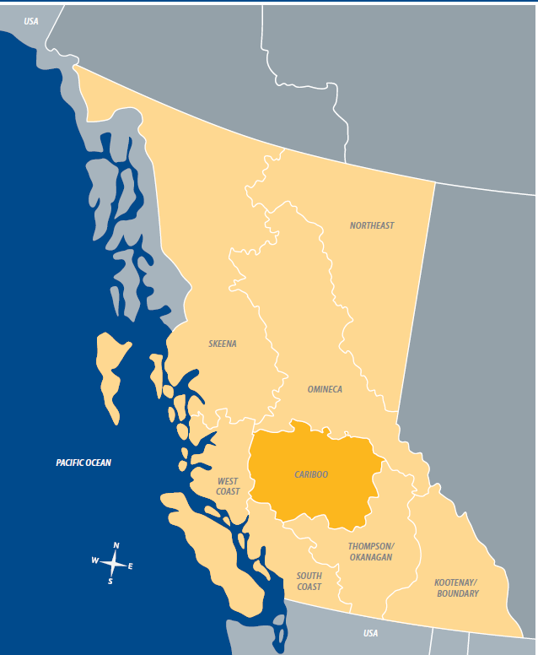

For background and contact information for Major Project Offices:

http://www.for.gov.bc.ca/ftp/Major_Projects/external/!publish/Web/Mining/GDU618_Info%20Sheet%20Major%20Projects_v1.pdf

Ministry of Environment - Environmental Protection Office
The Environmental Protection Division of MOE works to prevent pollution and promote and restore environmental quality. Its business goals include:
Pollution prevention;
Continuous improvement in Air, Land and Water Quality; and
Fully engaged partners.
The Regional Operations Branch of the Environmental Protection Division has nine regional offices whose staff ensures safe discharges to water, land and air through authorizations and under voluntary arrangements with others.
Environmental Protection Division: https://gww.nrs.gov.bc.ca/env/environmental-protection-division/environmental-protection-division
Regional offices; http://www.env.gov.bc.ca/main/regions.html

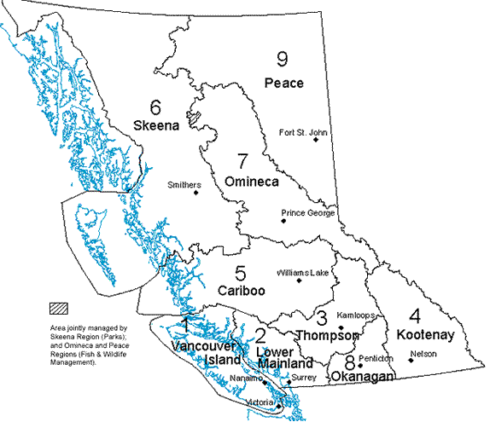

APPENDIX 1 Project Description Template
The project description template can be downloaded from the Major Projects Office website: http://www.for.gov.bc.ca/major_projects/mining/

APPENDIX 2 Detailed Mine Life Cycle
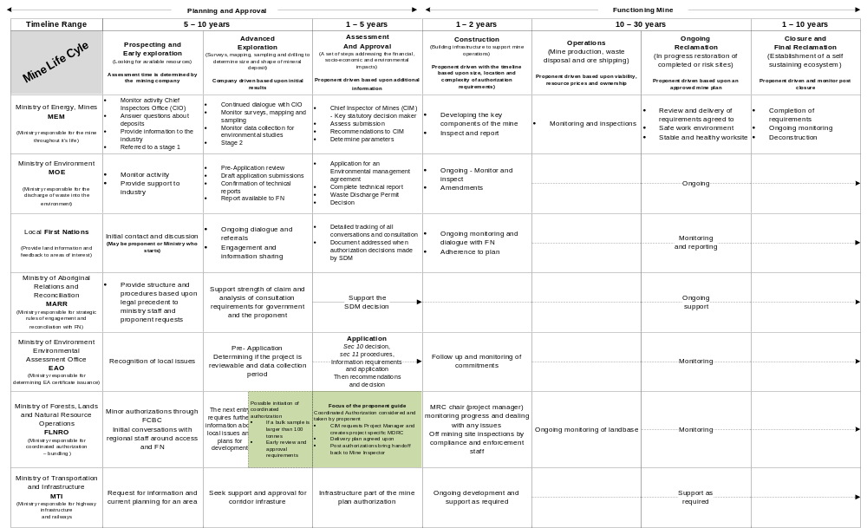

APPENDIX 3 Coordinated Authorizations Process for Mines
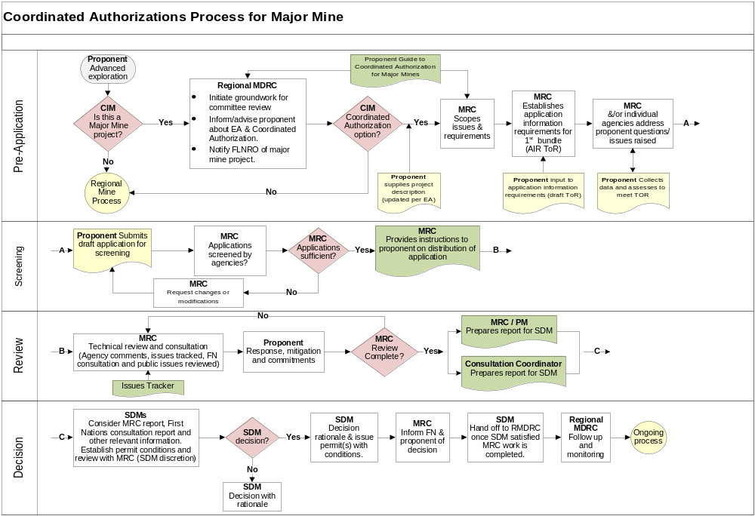
APPENDIX 4 Consultation Information Checklist, Tracking and Logs

Contents Checklist
Proponent Information
 Proponent Name
 Proponent contact information

Purpose/ Activities Information
 Purpose of the proposal and specific activity details
 Application type(s) being referred
 Planned year and season of operations
 Date to be contacted by/date to follow up by

Geographic / Location Information
 Geographic Location Identifier – Landmark i.e. Lake
 Map sheet and/or UTM coordinates
 Resource/Forest District

Site Specific/Adjacent Information
 Size of effected Area (ha)
 If building trails or roads: length of new road construction (est. km)
 If tree cutting: amount of merchantable timber to be removed (estimated) >50 m3?
 If occupation of the land: state purpose (e.g. camps)
 Proximity to Riparian or Water locations – Direct or Indirect association
 If known at time of engagement, provide details as follows:
o Fish Bearing stream location in relation to activity
o Wetland location in relation to activity
o Stream/wetland classifications for water bodies in/adjacent to proposed activity area
o Any fish bearing water bodies in area
o Wildlife Habitat Areas (WHA) or Wildlife Management Zones nearby. If so, reference
Archaeological, Cultural, and Heritage Values
 Archaeological Potential (low, moderate or high), for each location or road
 Completed cultural heritage surveys, Archaeological Overview Assessments or Archaeological Impact Assessments, Preliminary Field Reconnaissance
 Known Cultural Areas: Aboriginal Trails or Culturally Modified Trees
 Know Arch Sites: Identify area, archaeological ID #
 NOTE: If applicable, attach management strategies

Mapping Requirements
 PDF map at a scale between 1:10,000 and 1:50,000 that identifies the following:
o Location of newly proposed activities and roads
o Location of previously consulted areas and roads
o Parks, Protected areas
o Towns and Federal Reserve Land
o Lakes, streams and wetlands
o Established Ungulate Winter Range and Wildlife Habitat Areas
o Identified species at risk habitat
o Cultural heritage trails and features (where information is not subject to restrictions under sharing agreements)
o Recreation sites and trails
o UTM coordinates grid for geographic location

APPENDIX 5 Proponent Engagement Communication Log
 |  | Proponent Engagement Communication Log
 |  |  |  | PROPONENT NAME: |  |  |  |  |  | FLNRO CONSULTATION LEAD:
 |  |  |  | PROPONENT LEAD: |  |  |  |  |  | LOCATION (REGION/RESOURCE DISTRICT.):
 |  |  |  | PROPOSED PROJECT/ ACTIVITY(IES): |  |  |  |  |  | DATE COMM. LOG SUBMITTED TO PROVINCE:
First Nation |  | Date |  | Initiator of Communication |  |  | Initial Package, Follow Up, Additional Information, Etc. |  |  | Medium |  |  | Comments |  | Additional Information
Name of First Nation |  | Year/Mth/Day |  | Name of Band /Band Contact/Proponent Contact |  |  | Initial Package, Follow Up, Additional Information, Etc. |  |  | Email, Phone, Mail, Fax, Meeting |  |  | Brief |  | Ex. No Answer, Voicemail, etc.
APPENDIX 6 Proponent Engagement Interests/Concerns Tracking

Proponent Engagement Interests /Concerns Tracking
 |  |  | PROPONENT NAME: |  |  |  |  | FLNRO CONSULTATION LEAD:
 |  |  | PROPONENT LEAD: |  |  |  |  | LOCATION (REGION/RESOURCE DISTRICT.):
 |  |  | PROPOSED PROJECT/ACTIVITY(IES): |  |  |  |  | DATE COMM. LOG SUBMITTED TO PROVINCE:
 | Date |  | First Nation |  | Interest/Concern Raised (General or Site Specific) |  |  |  | Proponents Response |  | Interest/Concern Status |  |  | Comments |  | Additional Information
 | Year/Mth/Day |  | Name of Band /Band Contact/Proponent Contact |  | Details |  |  |  | How/if addressing concern/issue |  | Resolved / Outstanding |  |  | Brief Notes |  | Attachments, Notes, etc

APPENDIX 7 Proponent First Nations Engagement

INTRODUCTION
The Province of British Columbia encourages early engagement between Proponents and First Nations. Often Proponents can play an important role in the provision of information about their projects and proposed activities. This document sets out regional recommendations for Proponents engaging with First Nations.
Proponents are encouraged to strive toward completing information sharing on activities prior to the Province accepting an application. However, if the application has already been submitted, the Province and Proponent will work jointly to engage with First Nations. Upon receiving an application, the Province must contact the First Nation prior to consultation commencing, at which point the Province must advise the First Nations of the role and responsibilities of the Province and the appropriate roles of the Proponent in the consultation process and the intended decision date. Both the Proponent and Province, upon initiating engagement, must state that the Proponents efforts will be recorded and incorporated into the Province’s Consultation Record.
Note: If a First Nation is unwilling to meet directly with the Proponent, and wishes to meet with government staff (either alone, or together with the Proponent), the Province will respect that view.

BEST PRACTICE #1: PREPARING TO ENGAGE
There are two phases to engagement: pre-application and application/consultation. For pre-application engagement, Provincial staff can provide advice based on a scan of aboriginal interests in the area1. Upon receiving an application, before commencing consultation, Provincial staff must conduct an Initial Review as described in the Provincial Procedures and establish an initial level of engagement/consultation. This will include reviewing First Nations contacts identified in the Consultative Area Database and other related readily available information, including general archeological and historical information. This is also an opportunity for government to clarify any protocols contained in agreements with First Nations. If pre-application information sharing has taken place between the Proponent and First Nation, the Province will also review the findings from this early engagement.
Note: though the Province can provide advice regarding which First Nations to focus engagements, at this point not all information may be available and that research and discussions with the First Nations may be required once the consultation process has been triggered.

BEST PRACTICE #2: CONTENTS FOR INFORMATION SHARING
The Proponent is expected to share information directly with the applicable First Nations and the Provincial First Nations Relations staff. Proponents are encouraged to provide the information noted in the document embedded below as early as possible. Early information sharing is advantageous as it enables resolution to any potential issues quickly through direct discussion with the affected First Nations. If done in a timely manner, this will negate the need to extend the consultation period.

BEST PRACTICE #3: PRE-APPLICATION ENGAGEMENT AND CONSULTATION
When the Proponent conducts information sharing or takes on the procedural aspects of consultation they must keep a record of communication (see tab 1 of tracking template below) identifying each First Nation, the person communicating with the First Nation, the communication format (letter, email, fax, meeting or phone call), dates, and general comments (such as information shared with the First Nation, minutes of meetings, and/or information captured on phone calls). Aside from tracking communication, Proponents are to also record aboriginal interest/concerns and related accommodation measures (see tab 2 of tracking table below). The information in these two tables will be added to the Provincial Consultation Record, which is submitted to the Statutory Decision Maker to support the decision making process. The Proponent should inform the First Nation that information collected will be shared with the Province. It is highly recommended that the templates are also used during pre-application engagement.

BEST PRACTICE #4: CONSULTATION INITIATION
Though the Proponent may begin early engagement, consultation is not triggered until the Province sends a letter referencing the Proponent’s information sharing package in addition to stating currently known aboriginal interests and past identified concerns and accommodations. The consultation clock starts here. This letter will clearly communicate the role of the Proponent, Province, and timelines. At this time, the First Nation may decide to engage solely with the Proponent, solely with the Province, or jointly with the Proponent and Province. Additionally, After the Province has sent the initial communication triggering consultation the First Nations may wish to provide input to the Province on the Initial Review (First Nations interests, potential impacts, etc.). If the First Nation wishes to respond to the Province, this information may be shared with Proponent.

BEST PRACTICE #5: ACCOMMODATION MEASURES
Accommodation includes activities to avoid or mitigate adverse impacts or concerns respecting aboriginal interests brought forwards by a First Nation during engagement.
Accommodation options could include:
• Changing the timing of a proposed activity;
• Altering the footprint or location of a proposed activity;
• Avoiding the aboriginal interest;
• Environmental monitoring; and,
• Other mitigation strategies (i.e. agreements).

BEST PRACTICE #6: FOLLOWING UP
If the First Nation has not engaged with the Proponent or the Province, the Province will follow up with the First Nation with a reminder of the decision deadline.
If the First Nation has engaged, and no new information is to be shared or required by the First Nation, the Proponent is to follow-up with First Nation to communicate their intention to send a summary of the findings and outcomes to FLNRO; the summary package sent to FLNRO should be shared with the First Nation as well. Communication between Provincial First Nations Relations Staff and the Proponent should also occur at this time.
BEST PRACTICE #7: SUMMARY STANDARDS
Proponents must submit to the Province the tracking templates and a summary of the information sharing and engagement process, which should meet Provincial expectations regarding content/detail as to ensure consultation has been adequate.

BEST PRACTICE #8: CONFIRMATION OF INTERESTS/CONCERNS RAISED BY FIRST NATIONS
Provincial First Nations Relations Staff will confirm with Proponent that Provincial and legal requirements have been met, discuss any outstanding concerns raised by First Nations, and consider whether further First Nation engagement is necessary. If consultation is not deemed as adequate further consideration to process and timelines should be given.

Best Practice #9: FINAL LETTER TO FIRST NATIONS
Provincial First Nations Relations Staff to send First Nations a final letter regarding conclusion of consultation with the proponents to be copied. This concludes the formal consultation period.

